 | FPT ACADEMY INTERNATIONAL  FPT - APTECH COMPUTER EDUCATION

Petcare Website
Installation Guide

Center Name |  | ACE-HCMC-2-FPT  Address: 590 Cach Mang Thang Tam, District 3, HCMC, Vietnam.
Instructor |  | Mr. Hoang Duc Quang
Class |  | T1.1804.M1
Group |  | 02
Group members |  | Name | Student ID
 |  | Ngo Duy Phuong | Student1099152
 |  | Le Gia Phuc | Student1093602
 |  | Phuong The Vi | Student1098853
 |  | Bui Duc Dung | Student1093640
Duration | Start date | December 07th 2020
Duration | End date | February 27th 2019

Software and Hardware Requirement

Hardware requirement

Component | Requirement
Server | Processor type:  Pentium III-compatible processor or faster  Processor speed:  Recommended: 2.0 GHz or faster
OS | Microsoft Windows Server 2003 or higher
Memory (RAM) | RAM:  Minimum: 512 MB  Recommended: 2.048 GB or more  Maximum: Operating system maximum
Hard Drive | Free space:  Minimum: 50 MB  Recommended: 50 GB or more  Maximum: Operating system maximum

Software requirement
Component | Requirement
Netbeans IDE | Version 8.2 or higher
RDBMS | Microsoft SQL Server 2017 or higher
Server | Glassfish 4.1 or higher
Web Browser | Chrome (recommended), Firefox, IE 7 or higher

Configuration

Configure Admin Console on Glassfish.
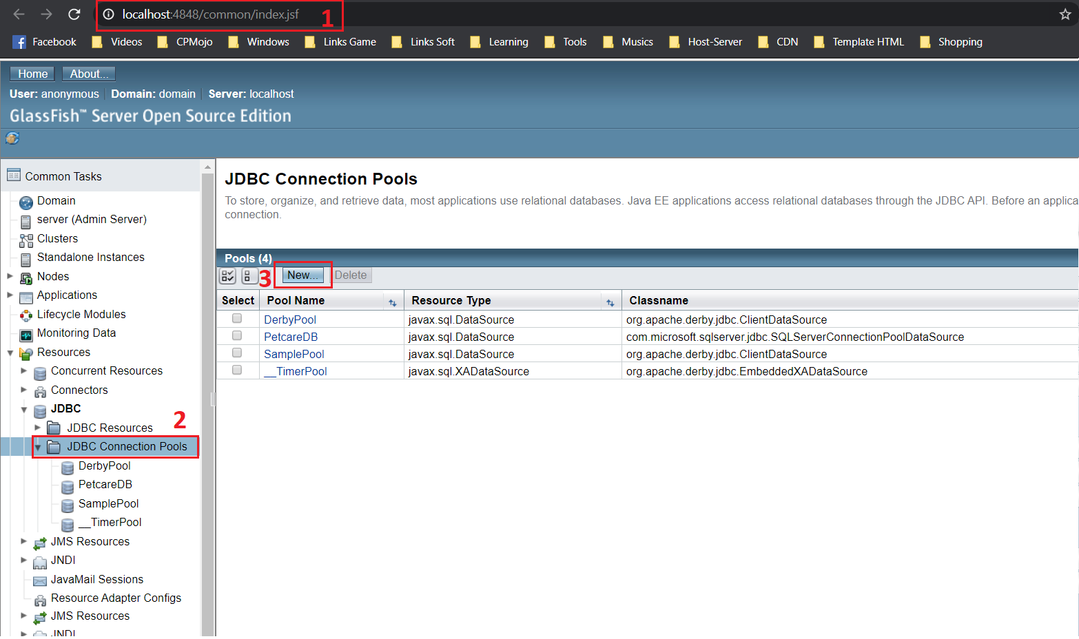

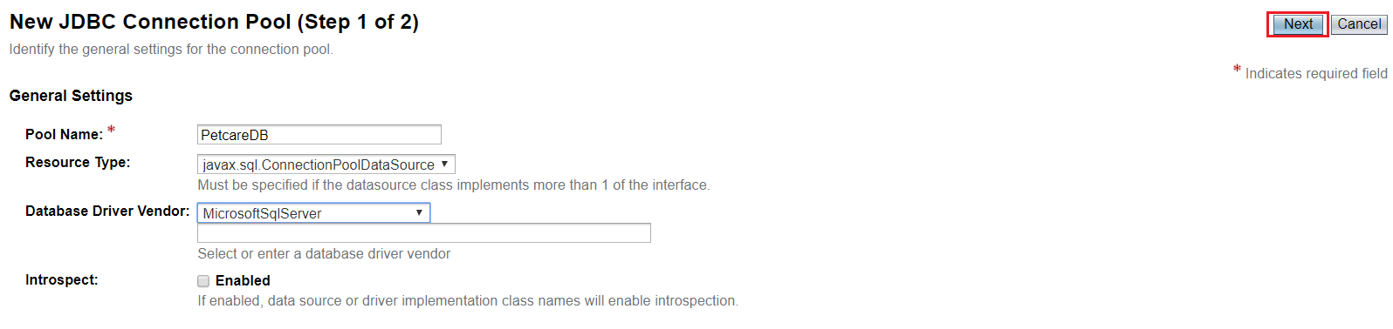

Fill out Addition properties follow:
- DatabaseName: PetcareDB
- User: sa (your username of SQL Server)
- Password: your password of SQLServer
- URL: jdbc:sqlserver://localhost:1433;databaseName=PetcareDB
- ServerName : localhost
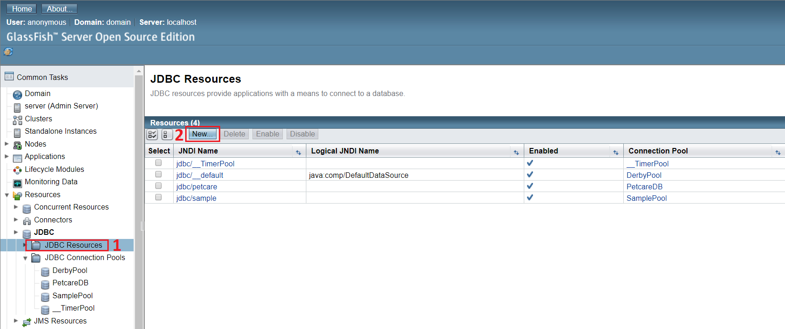

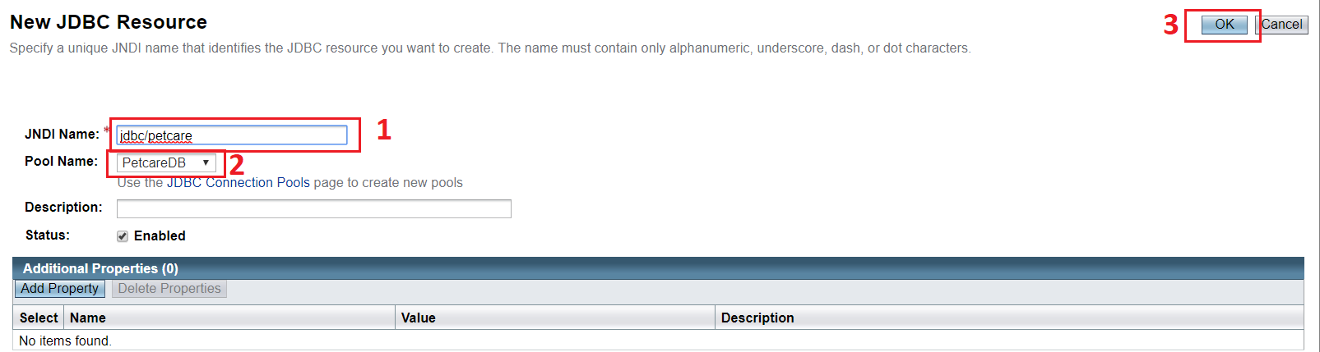

Install Database.

- Open file “Petcare/db/petcareDB.sql” by Microsoft SQL Server Management Studio.
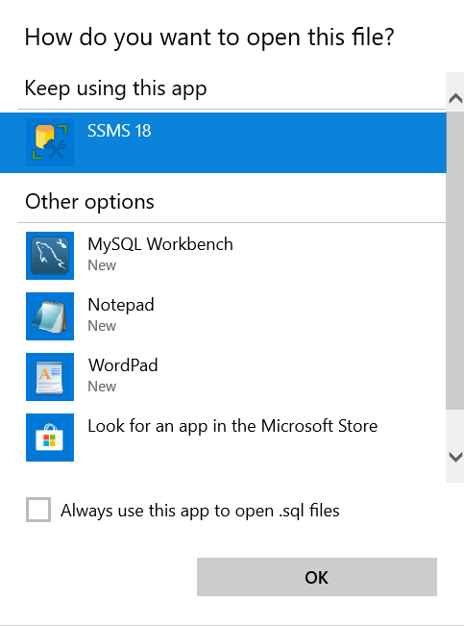

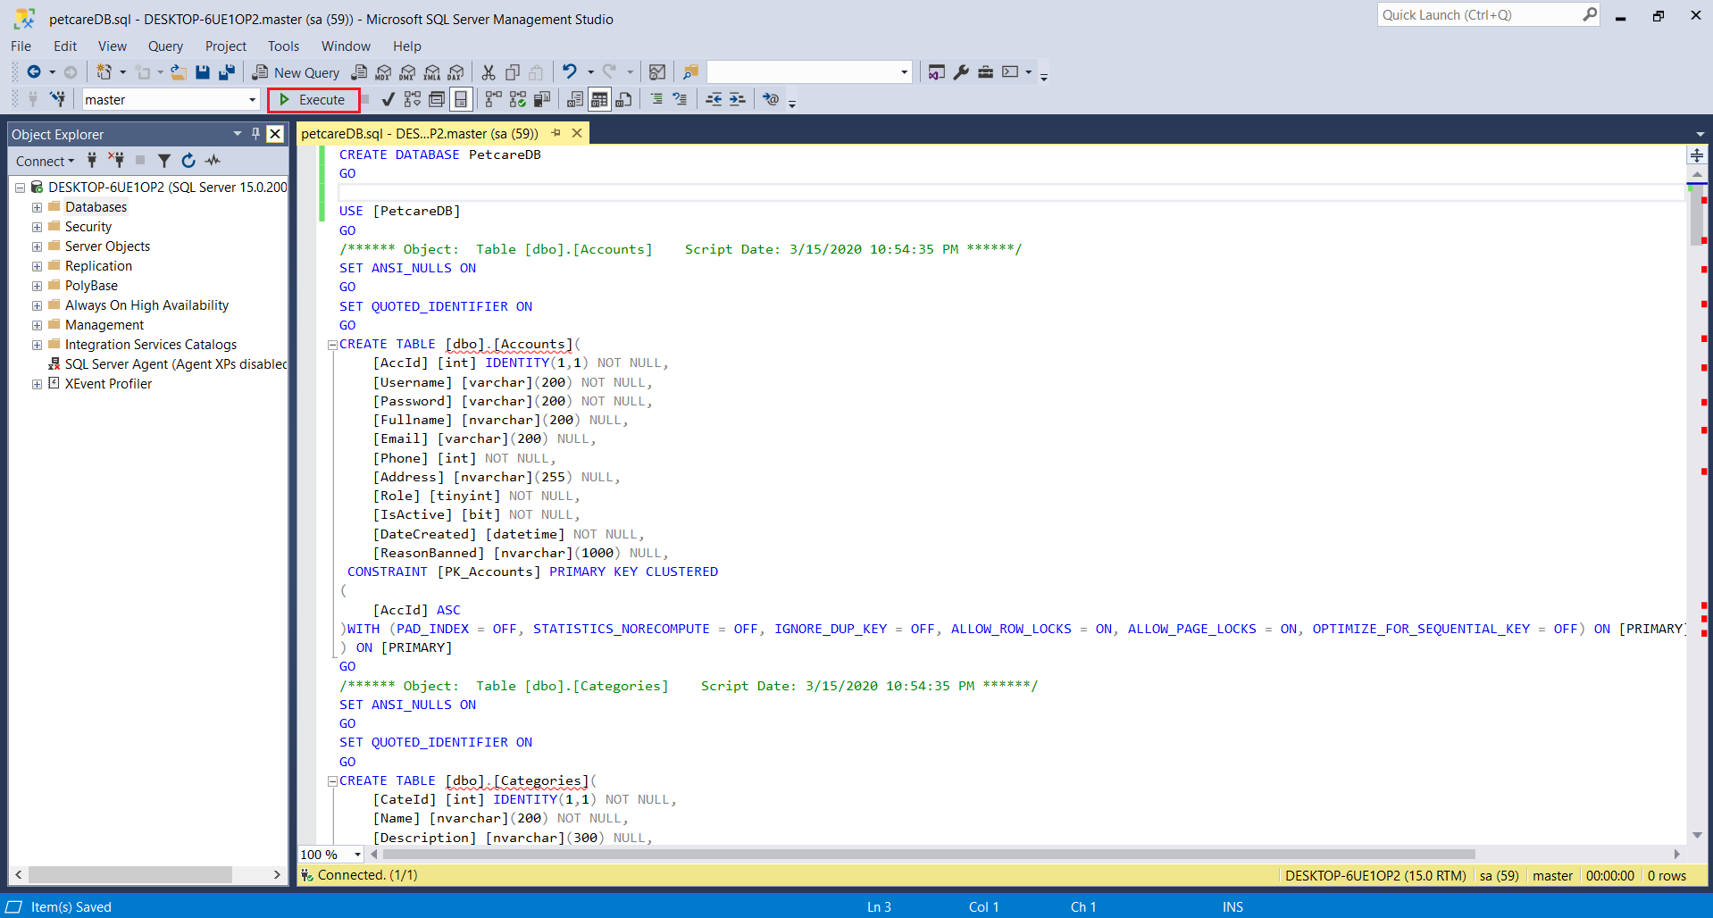

Publish Website
- Run Netbeans:
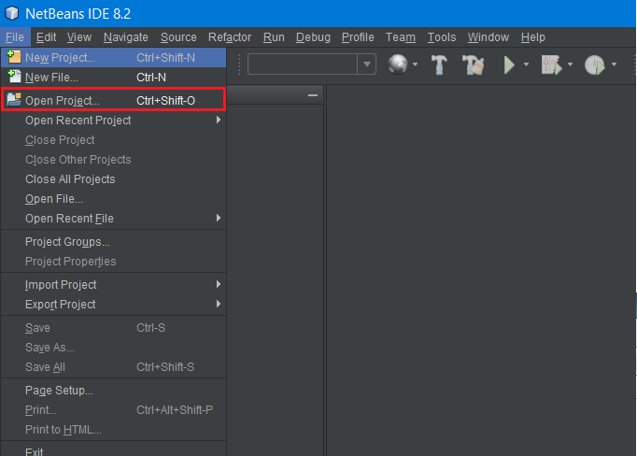
- Browse to Petcare:
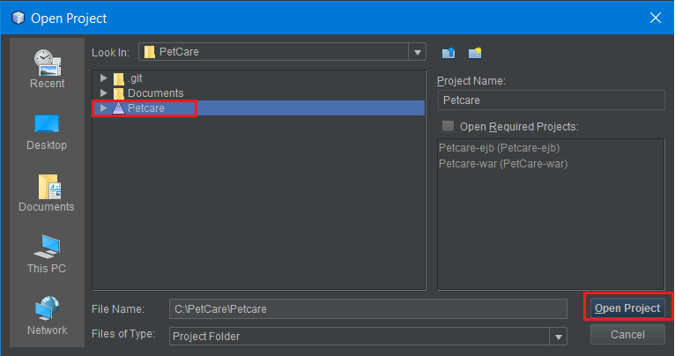

- Right click Petcare -> select Clean and build -> Deploy -> Run
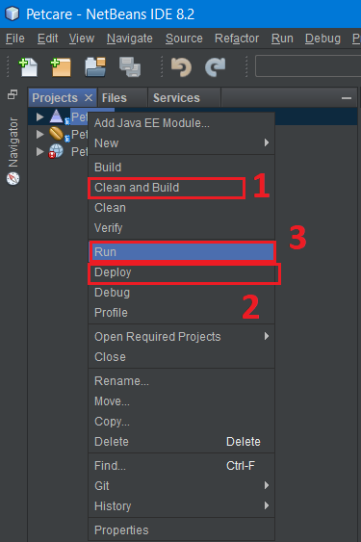
- Finish.



